Standard Operating Procedure (SOP) for Sampling Surface Waters for the pesticides Chlorantraniliprole and Neonicotinoids

Compiled 1/20/2026 by:
UCONN CESE Lab, Christopher Perkins, christopher.perkins@uconn.edu
East Norwalk Blue, Richard Harris, rbharris39@gmail.com
CT Pesticide Reform, Joan Seguin, traceyseguin@gmail.com

Pesticides applied to lawns and gardens can be unintentionally transported into nearby waterways and are often routinely found in CT rivers at elevated levels. Analyzing surface water aids in the understanding of the potential for everyday pesticide use to contaminate local watersheds with corresponding impacts to human health, aquatic life and the ecosystems they support.

Neonicotinoids (imidacloprid, clothianidin, thiamethoxam, dinotefuran, acetamiprid, and thiacloprid) are insecticides used on lawns, gardens and in agriculture. Imidacloprid is the one found in Connecticut rivers at the highest levels and is the focus of testing for the Clean Rivers projects organized by East Norwalk Blue, Norwalk River Watershed Association, CT Audubon and partners. Chlorantraniliprole, a diamide also used on lawns and gardens as well as in agriculture, is also a focus for this project. Chlorantraniliprole use is on the rise for treatment of grubs in lawns as grubs are becoming resistant to imidacloprid and use of imidacloprid on lawns will be severely restricted in Connecticut beginning in 2027.

- SAMPLE ANALYSIS: The Center for Environmental Sciences and Engineering, Connecticut University

All surface water samples will be processed at The Center for Environmental Sciences and Engineering at the University of Connecticut, Building 4, Annex 3107, U-4210 Horsebarn Hill Road, Storrs, CT, under the direction of Lab Director Christopher Perkins.

Chlorantraniliprole
Samples are analyzed for chlorantraniliprole and its known degradants using a modified United States Geological Survey (USGS) method, which employs graphitized carbon-based, solid-phase extraction and high-performance liquid chromatography/quantitative time-of-flight mass spectrometry (Furlong, et al., 2001). The laboratory provides all sample bottles, which are pre-cleaned sterile 250 mL, high-density polyethylene (HDPE).

- Samples must be collected during low or ebbing tidal conditions. Sample collection may begin no earlier than 1.5 hours after high tide and may continue through 1.0 hour after low tide.
- Samples should be collected at a depth of 12-18” from stations where the water depth is >2 feet. If there is less than 2 feet of water at the station location, note the approximate depth under “notes” on the laboratory collection form. If wading in to collect samples, avoid disturbing the sediment as much as possible and always sample upstream from where sample collector is standing.
- Chlorantraniliprole is an insecticide commonly applied to lawn and turf areas in the spring. To capture the potential runoff of chlorantraniliprole into the watershed, sampling should be conducted in mid-spring, specifically between May 15 and June 5.
- To the extent practicable, samples should be collected following a rainfall event to maximize the likelihood of detecting runoff-related contaminants from turf and lawn areas into adjacent surface waters. Ideally, samples will be collected within 0–4 days following a rainfall event of at least 0.5 inches.

Neonicotinoids
Samples are analyzed for the Neonicotinoids Imidacloprid, nitenpyram, thiamethoxam, clothianidin, acetamiprid, thiacloprid, and fipronil using a modified United States Geological Survey (USGS) method, which employs graphitized carbon-based, solid-phase extraction and high-performance liquid chromatography/quantitative time-of-flight mass spectrometry (Furlong, et al., 2001). The laboratory provides all sample bottles, which are pre-cleaned sterile 250 mL, high-density polyethylene (HDPE) (Furlong, et al. 2001).

- Samples must be collected during low or ebbing tidal conditions. Sample collection may begin no earlier than 1.5 hours after high tide and may continue through 1.0 hour after low tide.
- Samples should be collected at a depth of 12-18” from stations where the water depth is >2 feet. If there is less than 2 feet of water at the station location, note the approximate depth under “notes” on the laboratory collection form. If wading in to collect samples, avoid disturbing the sediment as much as possible and always sample upstream from where sample collector is standing.
- Neonicotinoids are an insecticide commonly applied to lawn and turf areas in the summer. To capture the potential runoff of neonicotinoids into the watershed, sampling should be conducted in mid-summer, specifically between July 15 and August 5.
- To the extent practicable, samples should be collected following a rainfall event to maximize the likelihood of detecting runoff-related contaminants from turf and lawn areas into adjacent surface waters. Ideally, samples will be collected within 0–4 days following a rainfall event of at least 0.5 inches.
- SAMPLE COLLECTION PROCEDURES
Materials/Equipment
- 250 mL, high-density polyethylene (HDPE)
- Cooler (Styrofoam for shipping)
- Ice/Ice packs
- Sampling logs
- Adjustable stainless steel pipe clamps
- iPhone or other instrument to record GPS coordinates
- waterproof marker (Sharpie)
- Philips screwdriver or nut driver for adjusting stainless steel clamps
- Nitrile gloves
- Extendable aluminum rod with sampling plate
- A 250 sterile HDPE bottle filled with distilled and sterile water
- Chain of Custody documents
- Camera/iPhone
- Trash bag
- Tide Chart

Field Sample Preparation
Prior to leaving for the field, the following items are prepared for taking samples.
- Sample station locations are identified on a map and assigned a unique station ID
        - Field Trip Blanks will be denoted with “FTB”
        - Sample station duplicates will be denoted with station ID-“dup”
- A data sheet for recording station ID date, time, GPS, weather conditions and landmarks for reference (See Appendix A)
- A detailed map of the area to be surveyed showing roads, waterways and boundary lines.
- Pack enough 250 mL sterile HDPE bottles to sample each site, including sample duplicates, and field trip blank (FTB). Bottles should be transported in a cooler(s) with sufficient ice packs to keep the temperature at <10 ºC. Each bottle should be marked at a height of 3 inches with a waterproof marker (sharpie) and fitted with a stainless-steel pipe clamp at that line. The 3-inch line indicates the proper sampling depth and the metal clamp is used to secure the bottle to the test plate during sample collection (Figure 1).
- Pack extra stainless-steel clamps to secure sample bottles on the underside of the test plate when taking samples (Figure 2) and a Phillips screwdriver or nut driver is used to adjust the diameter of the clamps.
- An extendable aluminum rod with attached stainless steel sampling plate that can hold two 250 mL bottles for taking single and duplicate surface water samples (Figure 3). (In the event that a sample rod is not equipped to take duplicate samples simultaneously, then a duplicate sample can be collected immediately after initial sample following exact same procedure)
- Pack enough Nitrile gloves to provide clean handling for each sample collected in the field, gloves must be changed between samples.
Sample Collection:
Field Trip Blanks (FTBs) are collected as a QA/QC measure to assess potential contamination introduced during sample handling, transport, and storage.
Field trip blanks are taken to ensure that filtered and sterile dilution water used in the analysis of pesticides can be taken to the field and transferred to a second sterile, HDPE bottle without introducing any contamination associated with the handling and transport of samples.
A field trip blank will be prepared upon arrival at the first sampling location.
- The individual collecting the sample will put on a pair of disposable nitrile gloves.
- Remove cap from the laboratory-supplied 250 mL sterile water container and transfer the water to a sample bottle. Take care to not contaminate the interior of the bottle, cap or cap threads at any time.
- Once the bottle is filled, carefully recap the sample ensuring adequate air space if samples are to be shipped frozen.
- Label the sample “FTB” with a waterproof marker (sharpie) and place in cooler, where the temperature is maintained < 10 degrees C.
One FTB is required per sampling day to help ensure that sterile sampling techniques have been employed throughout the field work. Nitrile gloves are single-use and will be discarded after each sample collected. The field trip blank will be handled, stored, and analyzed in the same manner as all other samples, and should show no evidence of any contamination upon analysis by the UConn laboratory.
Surface Water Samples:
- Upon arrival at each station, the sample collector will put on a clean pair of disposable nitrile gloves.
- Remove a sterile 250 mL HDPE bottle from the cooler and mark the station ID and date on the bottle with a waterproof marker.
- The sample bottle is affixed to the sampling rod.
      - The sample bottle is placed into the opening of the sampling plate until contact is made with the pipe clamp at the proper 3” level.
      - A second pipe clamp is then attached, and a screwdriver is used to adjust the clamp diameter to secure the bottle to the underside of the plate (Figure 2). to keep the bottles from floating out of the sampling plate
- Remove the bottle cap. Do not contaminate the interior of the bottle, cap or cap threads at any time
- Lower the sampling plate to a depth of 18”. Once the bottle is filled, raise the sample and carefully recap the sample ensuring adequate air space to allow for the expansion of the liquid if samples are to be shipped frozen.
- Remove the bottle from the sample rod by removing both sets of metal clamps with the screwdriver
- Immediately store the sample bottle in the cooler where the temperature is maintained <10ºC.
- Dispose of nitrile gloves in trash bag.
- Record field data on our sample log. Record: Sample site ID, date, time of sample collection, and other field information on the sample log sheet.
- Take sample location

Samples Duplicates of surface water:
Stations identified for duplicate samples are collected in the same manner as regular samples.

- Two HDPE bottles are marked with the station ID and station ID-dup plus date on the bottles using a waterproof marker.
- Duplicate samples can be collected after both HDPE bottles are secured to the stainless-steel sampling plate down as described above.
- Both sample caps are removed and samples are collected simultaneously and stored in the cooler as described in steps above.

In the event a sample rod is not equipped to take duplicate samples simultaneously, then a duplicate sample can be collected immediately after initial sample following exact same procedure described in steps above.

REMINDER:
Samples should be collected at a depth of 12-18” from stations where the water depth is >2 feet. If there is less than 2 feet of water at the station location, note the approximate depth under “notes” on the laboratory collection form.
If wading in to collect samples, avoid disturbing the sediment as much as possible and always sample upstream from where sample collector is standing.

Sample Log (See Appendix A):

Record field data on log sheet and take one or more photos of the station.

      - Be sure to record time of sample collected (24 hour clock)
      - Time of high tide prior to start of sampling
      - Record any recent rainfall amount and date prior to sampling
      - Record the GPS of each station location (You can record GPS coordinates on an iPhone using built-in apps like Maps (drop a pin and swipe up) or Compass
      - Make note of any distinguishing landmarks that will help in future field work at the same test sites

- SAMPLE DELIVERY AND CHAIN OF CUSTODY

Upon completion of sampling, a chain of custody is prepared (Appendix B) and added to the cooler. The cooler is packed with ice packs and either delivered to the CESE Lab within 24 hours of sample collection or samples are frozen and shipped within 7 days by UPS or Fedex to the UCONN Laboratory at Storrs, CT for processing.

Sample Delivery (UCONN/CESE Laboratory)
Clients can drop off samples at the CESE Laboratories on the UConn Storrs campus or ship samples via UPS or FedEx (next-day service) to: 3107 Horsebarn Hill Road, Unit 4210, Storrs, CT 06269
To ensure sample integrity, please store samples in a cooler with ice packs until they are delivered to the lab. All samples shipped to the lab should be frozen prior to shipment or shipped in a cooler with ice packs.
CESE is open to receive samples Monday through Friday between 9:00 a.m. and 4:30 p.m. Sample drop-off may be available outside of normal hours with prior approval. Hours may change due to holidays and inclement weather.

Chain of Custody
All samples must be accompanied by a completed Chain of Custody (CoC) form.xlsx. This form provides CESE with the required information to correctly handle and process your samples, including sample identification; location, date, and time of collection; preservation type; sample matrix; and requested analytical tests.
»» Before dropping off or shipping your samples, please submit your Chain of Custody form online, https://uconn.kualibuild.com/app/67dab683ed0961027ddacd4f/start, print form and enclose in sample cooler. Please complete all fields and upload your CoC file(s).xlsx in Microsoft Excel format.

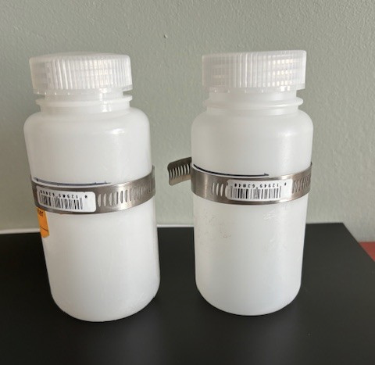

Figure 1. Two HDPE, 250 mL sample bottles with sterile pipe clamps at 3” mark prepared prior to field sampling.

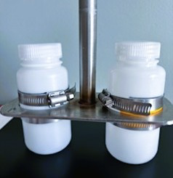

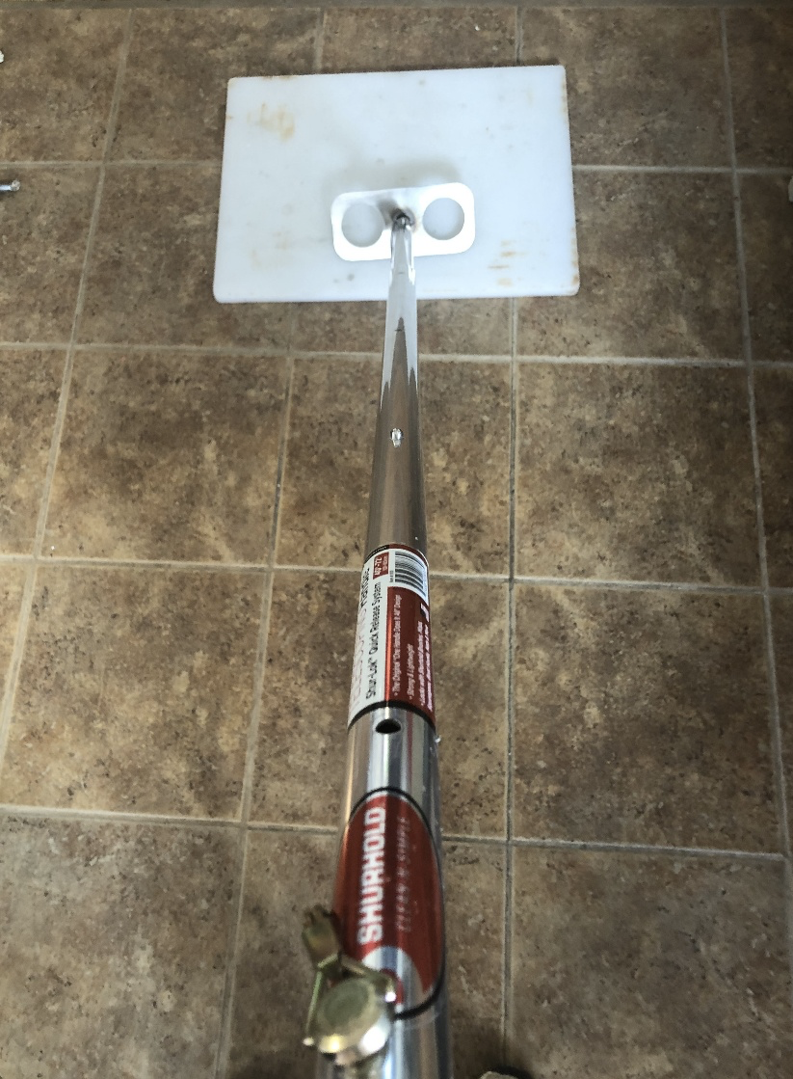
Figure 3. The extendable aluminum rod is used to lower the sampling plate with the attached bottles into the surface waters at the test site. A loop on the handle allows for an extra line to lower the unit from greater heights as needed.
Figure 2. Two HDPE sample bottles affixed to sampling plate with top and bottom metal clamps for duplicate sampling (Single samples affix only one sample bottle).

Appendix A: Water Quality Sampling Log

Project Name:______________________________________
Sample Collector: _________________________ Date Collected:_________________
Rainfall:________inches________ 24/48/72/96 (hrs before) HighTide:_______________
ALL SAMPLES MUST BE ICED IMMEDIATELY AFTER COLLECTION (<10ºC).

STATION ID | TIME  COLL. | DUPLICATE (Y/N) | LATITUDE | LONGITUDE | NOTES
FIELD TRIP BLANK |  | NA | NA | NA

Appendix B: Chain Of Custody
